Note: All the pictures are from the noun project.

1. Place: Maldives – The Paradise

Cost: $249 per person (family of 2)

Itinerary – Tour to the Maldives is for 5nights and 4 days. On the day one city male is going to be explored, it also contains dinner and a boat ride. Hotel picks up and drop is available. Day 2 will be about rides, and it has their separate rates. Scuba diving, sea walk, and many more water rides are there. You will be taken to the island, and till 5 pm, activities will stay available. Day 3 is vising the HP reef to see different types of corals and caves.

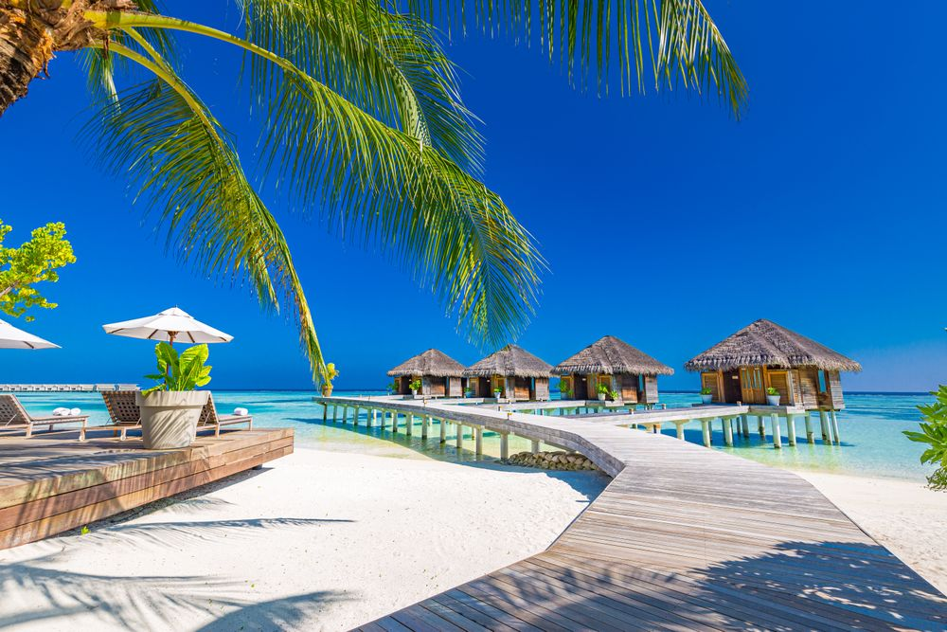

Day 4 is to enjoy the cruise party and visit the local islands around male city.

Place – Maldives

Cost - $300 per person (family of 4 – 6)

Itinerary – Tour to the Maldives is for 5nights and 4 days. On the day one city male is going to be explored. It also contains dinner and a boat ride. Hotel picks up, and drops are available. Day 2 will be about rides, and it has their separate rates. Scuba diving, sea walking, and many more water rides are there. You will be taken to the island, and till 5 pm, activities will stay available. Day 3 is visiting the HP reef to see different types of corals and caves. Day 4 is to enjoy the cruise party and visit the local islands around the male city. In this package, we will be providing rooms as per requirements.

2. Place – Dubai – Dream come true

Cost - $250 per person (Family of 2)

Dubai is the most beautiful place to visit with friends & family. There are so many places to explore. This tour is for 5 Nights and 6 Days. The first day will start with breakfast and then the butterfly garden. In that garden, they have huge creations of different types of cars and models. After that, the tour will be driven to Ferrari world, where there will be a car track. This tour will be like this till the last night it will cover all the famous museums and attractions. Last day there will be the see off dinner at the grand hotel and traditional dance for entertainment.

3 India – the Royalty

Cost: 500$(Family of 2)

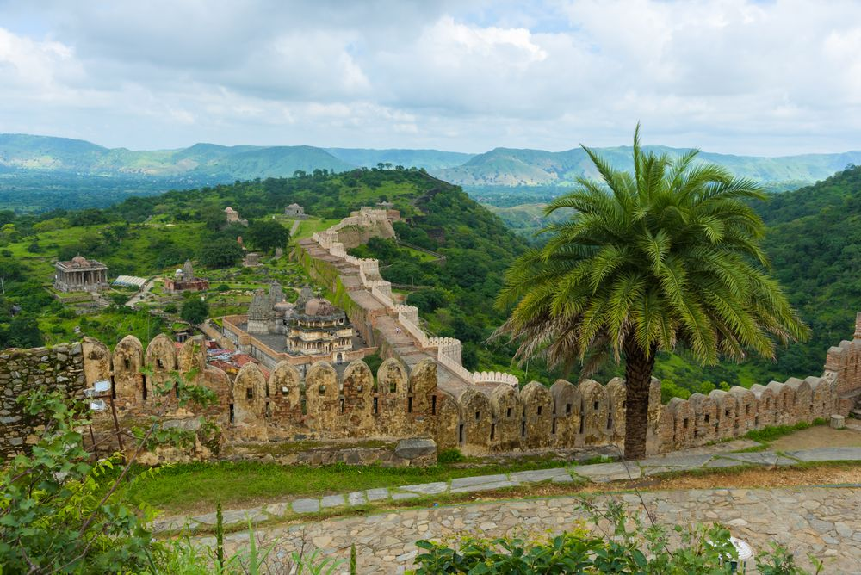

This tour will take you to the one of the wonders known as Taj Mahal. That is for the first day after that

4. South Africa - Nature’s own favorite

Cost 450$ (family of 2)

5. Egypt – Mystery of mummies

Cost: 700$ (family of 2)

6. Turkey – Places for Balloon

Cost: $499-699 (family of 4 Only)

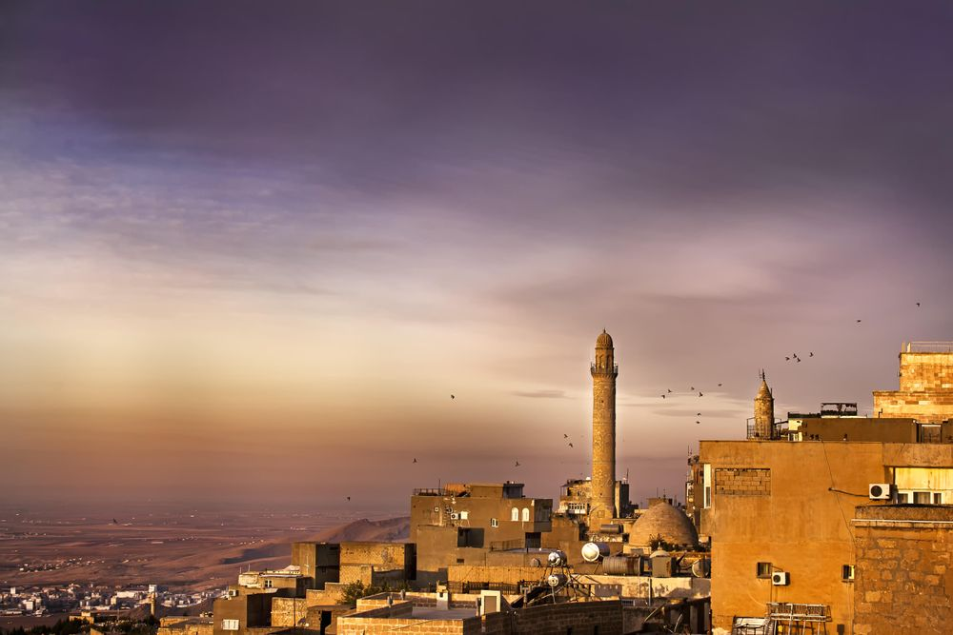

7. Thailand – Mighty wildlife

Cost: $800 (family of 4 only)

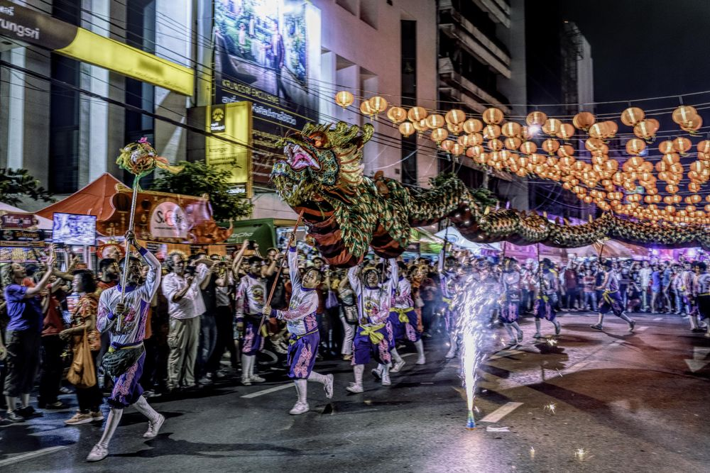

8. Nepal – The birthplace of Buddha

Cost: $500 (2 People)

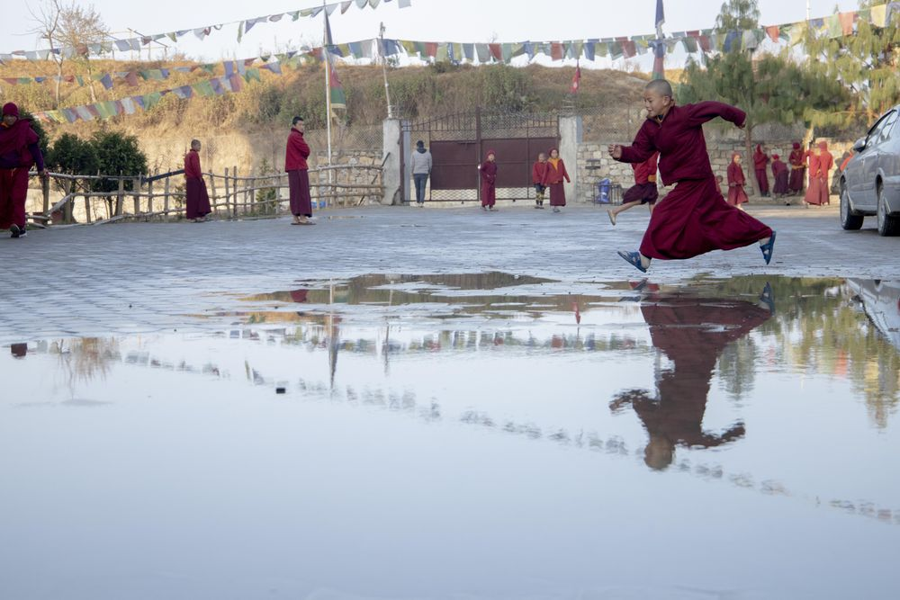

Content

## Taj Mahal - 1

Taj Mahal is the symbol of “Love.” It is also known as the crown of the Palace, made of ivory-white marble. It was built in 1653. People say that it started in 1632, and it took 20 years to complete the whole Palace. Mughal Shah Jahan was the King, and he built that for his lady love Mumtaz Mahal.

Since the Mumtaz died while giving birth to their 14th child, Shah Jahan wanted to build a memory palace in the memory of Begum. It is built with the inspiration from Indo-Islamic Architecture.

There are a few rumors that shah Jahan gave the punishment to their work as he cut their hand so that nobody could ever be built that again. To some extent, this rumor is faithful; he wanted to give so much perfection to this “Wonder” that the worker worked very hard. However, in terms of doing that, marble is so hard to give a shine that their skin started to pile off, and they got tons of burns on their hands.

In addition, there are two tombs in the main chamber, one of Mumtaz Mahal and the Second one of Shah Jahan. However, they are not the actual tombs; they are just two fake tombs to distract the public from the actual ones.

People say that they have seen the real ones located on the lower level of the Palace.

This is true. There are two original tombs of Mumtaz and Shah Jahan. Those are also made with the inspiration of Indo-Islamic Architecture. There is also an Arabic Ayat that is calligraphed on the main door of the Taj Mahal.

## Great Wall of China - 7

The great wall of China is located near Beijing. It is the largest building–construction project that has been structured. The China wall is about 5500 miles long; however, they claim 13,750 miles of the length. They started to work on this in the 7th century, and it continued for two millennia. It was initially built to get protection against various nomadic groups of the Eurasian Steppe.

There is a myth that this wall is visible from the moon, and while we did the research and come to the conclusion that from the lower orbit of the earth, it is barely visible, but when it comes to the equal surface, it is more visible than it is something build straight, and it is in the Asia Pacific continent.

The part which meets the sea in the vicinity of Shanghai pass is known as the old dragon head. In simple words, it is one end of the great wall of China. One more belief is that people used earth, wood, and stones before the bricks. Therefore, Bricks can hold more weight than wood, stone, and earth. That is how the construction quacked.

## Petra – 4

This wonder is located in Jorden and a remote valley, nestled among mountains, cliffs, and stones. It is known as the Khazna Petra. It was built in Roman times. The main thing is that they built a water system to promote gardening, which is a very high level of thinking to promote the architecture. The city of Petra was founded on a terrace carved from east to west by the Wadi Ms (Moses Valley)—one of the locations where, according to history, Moses broke rock and water flowed from.

Afterward, the Ancient peoples, an Arab tribe, founded it as their capital, and it developed during this era, becoming a major trade center, especially for spices. The Ancient people were expert carvers who engraved houses, churches, and graves into the sandstone, which changed color with the low sun. A large earthquake in 363 CE added to the obstacles, and Petra was ultimately abandoned with another earthquake in 551. Although this was identified in 1912, archaeologists primarily ignored it until the late twentieth century, and many doubts about the city existed.

## Machu Picchu -

Hiram Bingham “discovered” an Incan site in Cuzco, Peru, in 1911, assuming it to be Vilcabamba, a secretive Incan fortress utilized during the 16th-century resistance to Spanish rule. Despite the reality that this idea was ultimately rejected, the significance of Machu Picchu has puzzled historians. It was assumed by Bingham to be the location of the "Virgins of the Sun," women who lived in churches and fulfilled a purity oath. Others think it was just a royal getaway, while others believe it was a holy site. Machu Picchu is one of very few important pre-Columbian structures that have been rediscovered entirely intact. Agricultural fields, squares, residential areas, and churches exist despite its remote location higher in the Mountain Ranges.

## Christ the Redeemer

In Rio de Janeiro, Christ the Redeemer, a magnificent sculpture of Jesus, stands near Mount Corcovado. It originly can be traced back to the period after world War I, when some Brazilians feared a "flood of godlessness." They suggested a statue, which Heitor da Silva Costa, Carlos Oswald, and Paul Landowski eventually designed. Work began in 1926 and required years to finish. The structure's wide arms span 92 feet and it measures 98 feet (30 meters) tall (this does not include its base, which is roughly 26 feet (8 meters) tall (28 meters). It is Europe's greatest Art Deco monument. Christ the Redeemer is a strong concrete block with approximately six million tiles surrounding it. The statue has been damaged by lightening strikes multiple times, and in 2014, the tip of Jesus' right thumb was smashed during a hurricane.

## Colosseum

King Vespasian ordered the construction of the Colosseum in Rome during first century. The theater, which extends 620 by 513 feet (189 by 156 meters) and also has a complex system of tunnels, is a triumph of engineering. It could hold 50,000 spectators who wanted to appreciate a range of events. Gladiator fights were maybe the most recognized, but men battling animals was also common.

It is the best sign of ancient ROME. People used to play their traditional sports here.

Originally, the Latin word for the monument was simply amphitheater, which meant "outdoor stage." There is no proof that the modern name Flavian Theatre (Latin: amphitheater Flavium) was used in Ancient History. The name derives from the Flavian dynasty's patronage, under which reigns the structure was built, however, the monument is better known as the Colosseum. The Colosseum may have been understood in antiquity by the unofficial name By this Caesareum (with Caesareum to be an adjective going to refer to the title Caesar), but this name was not special to the Colosseum; the builders of the Colosseum, Vespasian, and Titus, also built a Flavian Pavilion in Puteoli.